

Sports Political Donations

**Engineering of Big-Data Systems**

**Fall 2020**

**INFO 7250 CRN 41798**

**Professor: Yusuf Ozbek**

**Kai Zhang**

**Dec 18, 2020**

**Summary:**

This dataset is from FiveThirtyEight. It contains every confirmed partisan political contribution from team owners and commissioners in the NFL, NBA, WNBA, NHL, MLB and NASCAR. Only contributions while owners were involved with the team are included. The data is from the Federal Election Commission and OpenSecrets.

sports-political-donations.csv

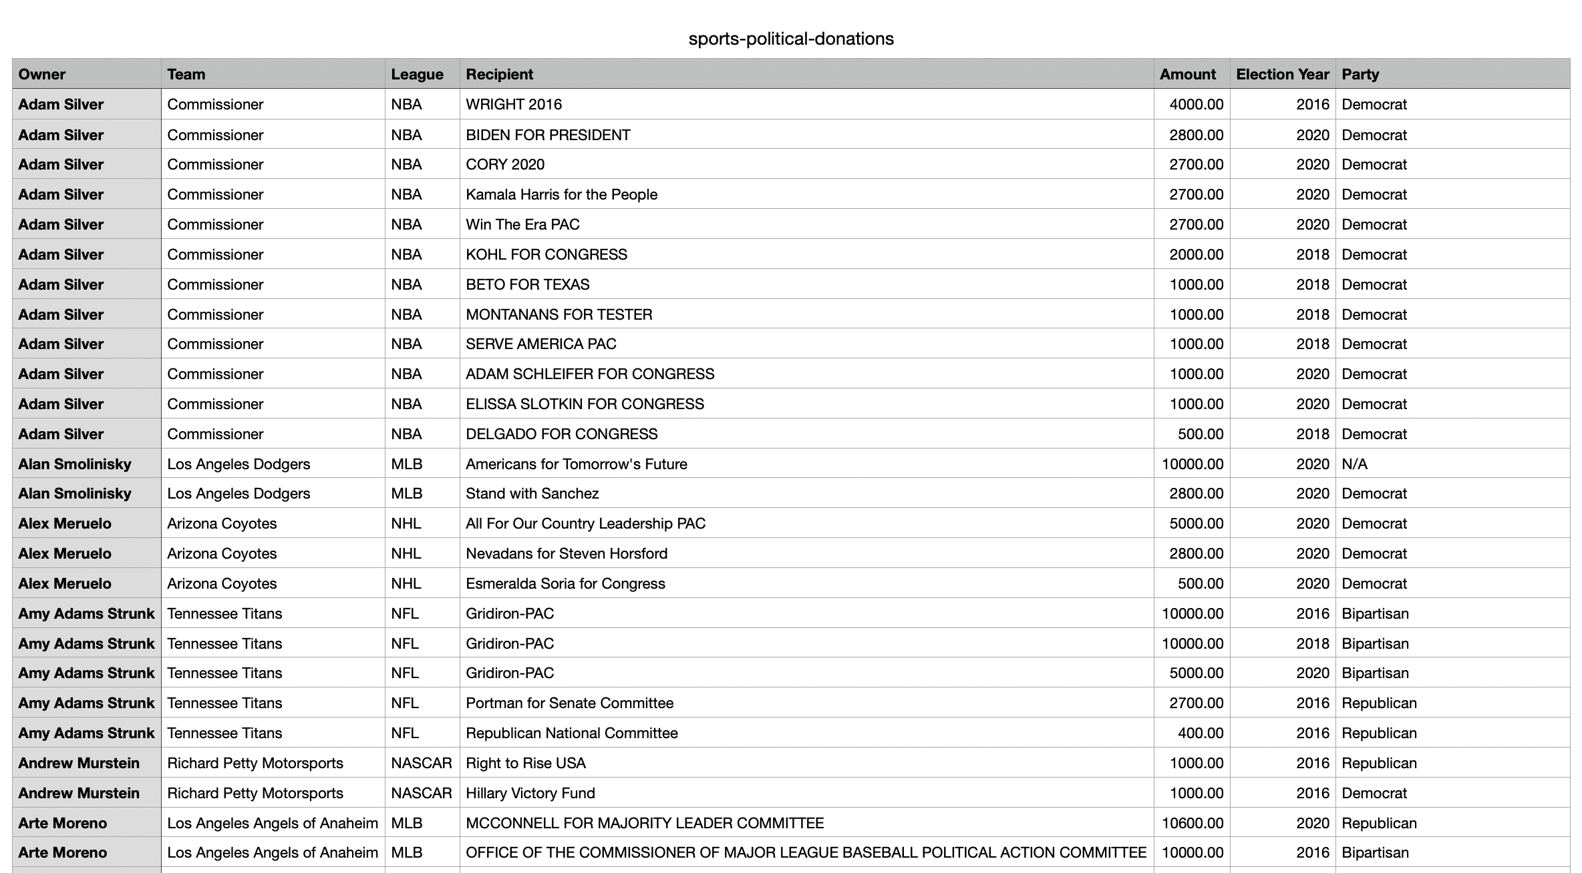

**Summary of analysis conducted:**

|  |  |  |
| --- | --- | --- |
| S.No | Description | Details |
| 1 | Find Top 10 owner’s total donation from 2016 to 2020 | HDFS |
| 2 | Count different leagues’ donation times, sum and average | HDFS |
| 3 | Count different leagues’ donation sum by party | HDFS |
| 4 | Find minimum, maximum, median, standard deviation of donation by party | HDFS |
| 5 | Find top 2 donation owners of each league | Pig |
| 6 | Count different leagues’ donation time by party | Pig |
| 7 | Find all donations over $200000 | Hive |
| 8 | Find all distinct Recipient | Hive |
| 9 | Find all donations from boston team | Hive |
| 10 | Count donation times from Boston team owner | Hive |

**Getting Started with HDFS**

Starting Hadoop

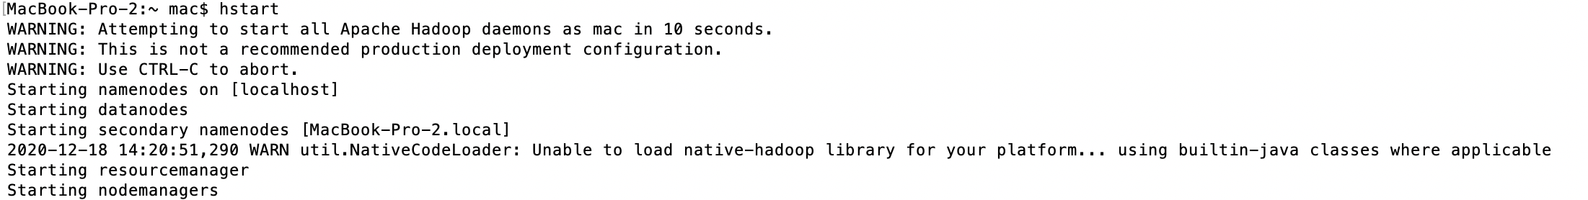

**Importing data into HDFS**

*hdfs dfs -copyFromLocal sports-political-donations.csv /sports-donations*

**Analysis #01 Find Top 10 owner’s total donation from 2016 to 2020**

/Final_Sports_Donations/src/main/java/OwnerCount

Sum each owner’s donation from 2016 to 2020and find the top 10 donated owners.

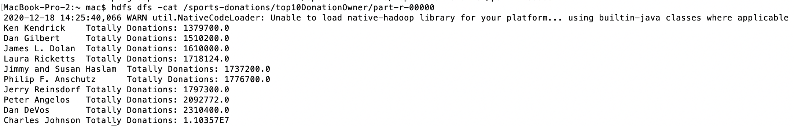

**Analysis #02 Count different leagues’ donation times, sum and average**

/Final_Sports_Donations/src/main/java/LeagueCount

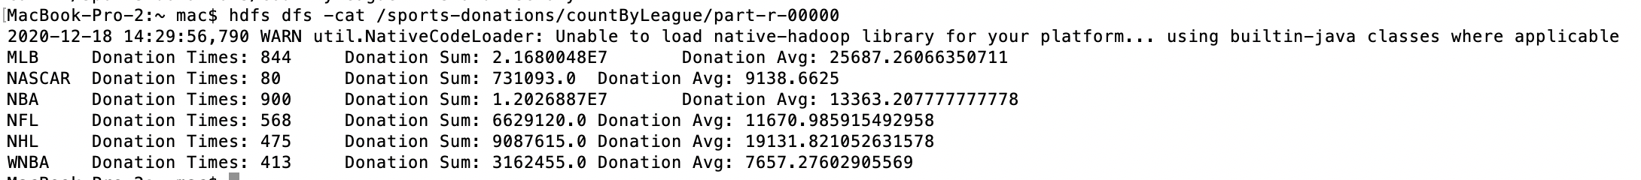

**Analysis #03 Count different leagues’ donation sum by party**

/Final_Sports_Donations/src/main/java/LeaguePartyCount

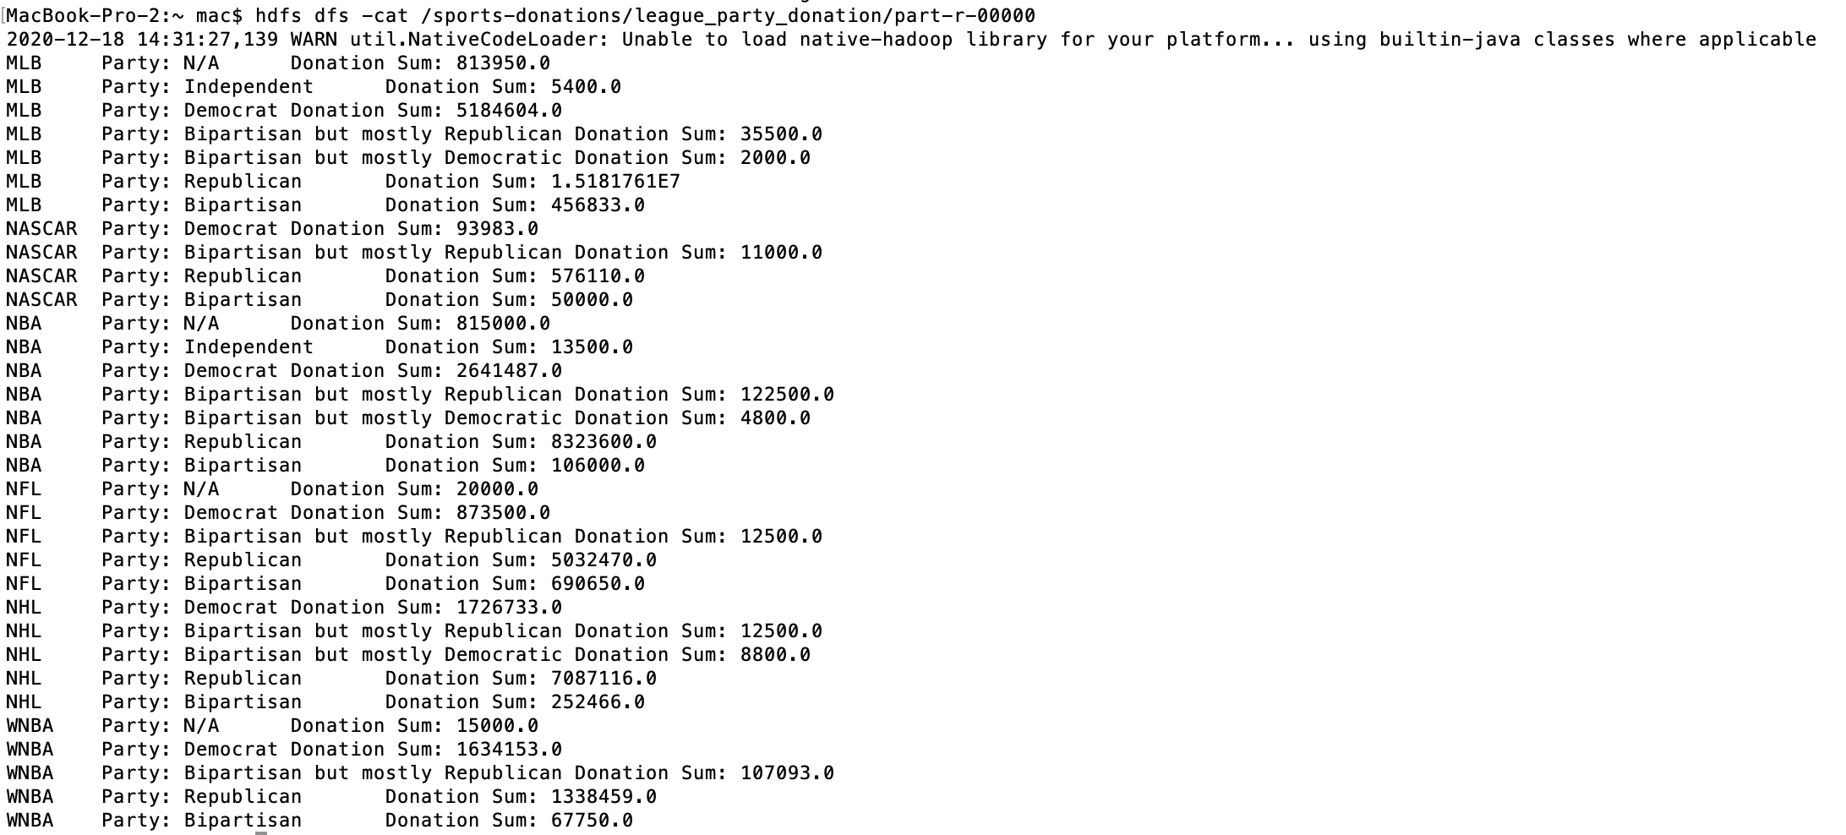

**Analysis #04 Find minimum, maximum, median, standard deviation of donation by party**

/Final_Sports_Donations/src/main/java/MinMax

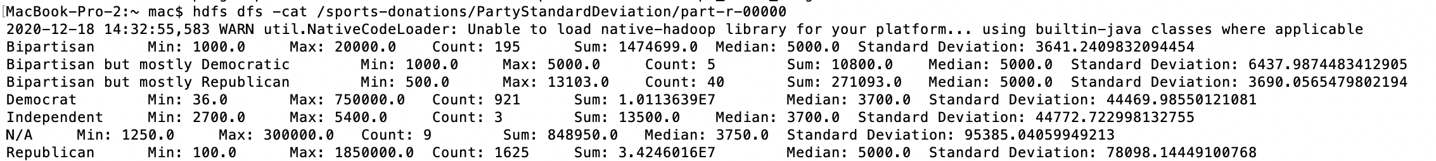

**Getting Started with Pig**

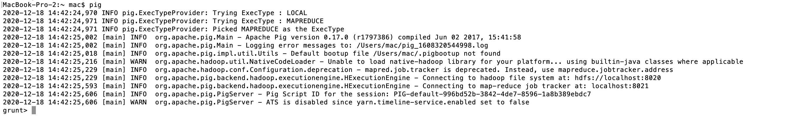

**Analysis #05 Find top 2 donation owners of each league**

**Pig Scripts**

*donations = load '/sports-donations/sports-political-donations.csv' using PigStorage(',') AS (owner, team, league, recipient, amount:double, year:int, party);*

*owner_group = GROUP donations BY (owner,team,league);*

*owner_sum = foreach owner_group Generate FLATTEN(group) AS (owner,team,league),SUM(donations.amount) as amount;*

*league_group = GROUP owner_sum BY league;*

*top2_league = FOREACH league_group {*

*sorted = order owner_sum by amount desc;*

*top = limit sorted 2;*

*generate group, flatten(top);*

*};*

*Store top2_league into '/sports-donations/top2_owner_league' using PigStorage();*

**Check HDFS**

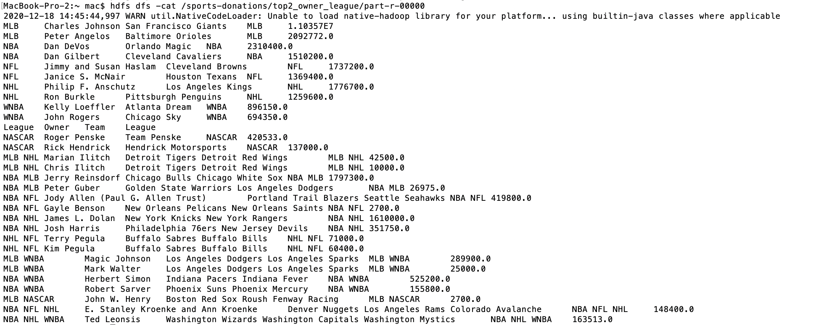

**Analysis #06 Count different leagues’ donation time by party**

**Pig Scripts**

*donations = load '/sports-donations/sports-political-donations.csv' using PigStorage(',') AS (owner, team, league, recipient, amount:double, year:int, party);*

*lpgroup = group donations BY (league,party);*

*league_party = foreach lpgroup Generate FLATTEN(group) AS (league,party), COUNT($1) as count;*

*order_league_party = ORDER league_party BY count DESC;*

*store order_league_party INTO '/sports-donations/league_party';*

**Check HDFS**

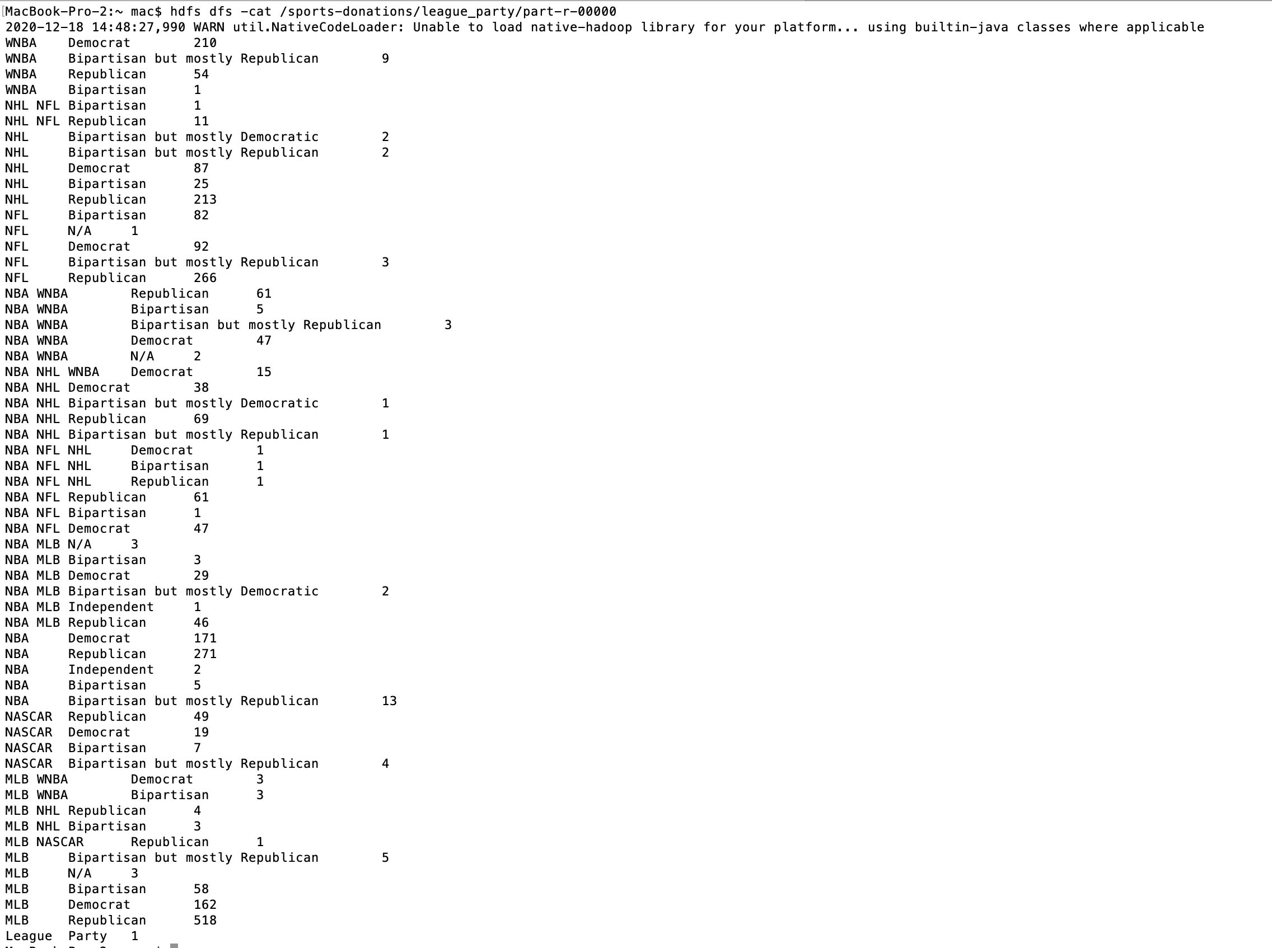

**Getting Started with Hive**

**Hive Create Table**

*CREATE TABLE donationTable (Owner String,Team String,League String,Recipient String,Amount Double,Year Int,Party String) ROW FORMAT DELIMITED FIELDS TERMINATED BY ',' LOCATION '/hive/donations';*

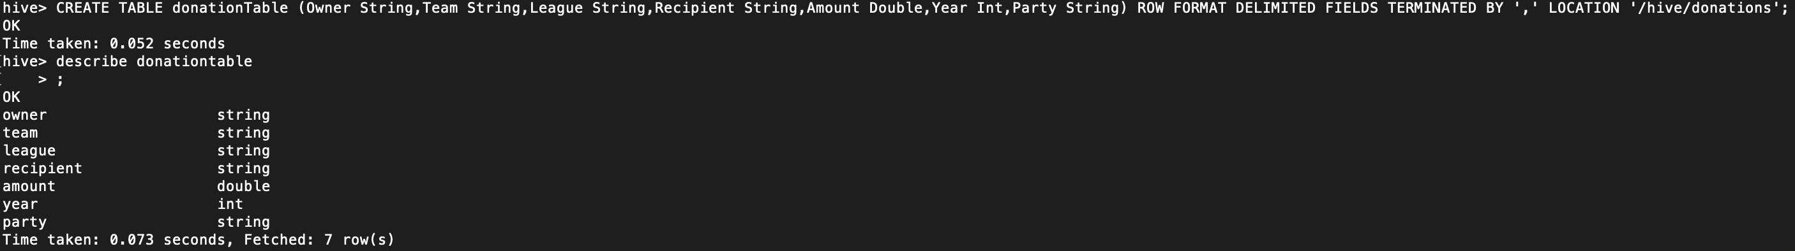

**Hive Load data from hdfs**

*LOAD DATA INPATH 'hdfs:/sports-donations/sports-political-donations.csv' INTO TABLE donationTable;*



**Analysis #07 Find all donations over $200000**

*Select owner, team, league, amount, year from donationTable where amount>=200000;*

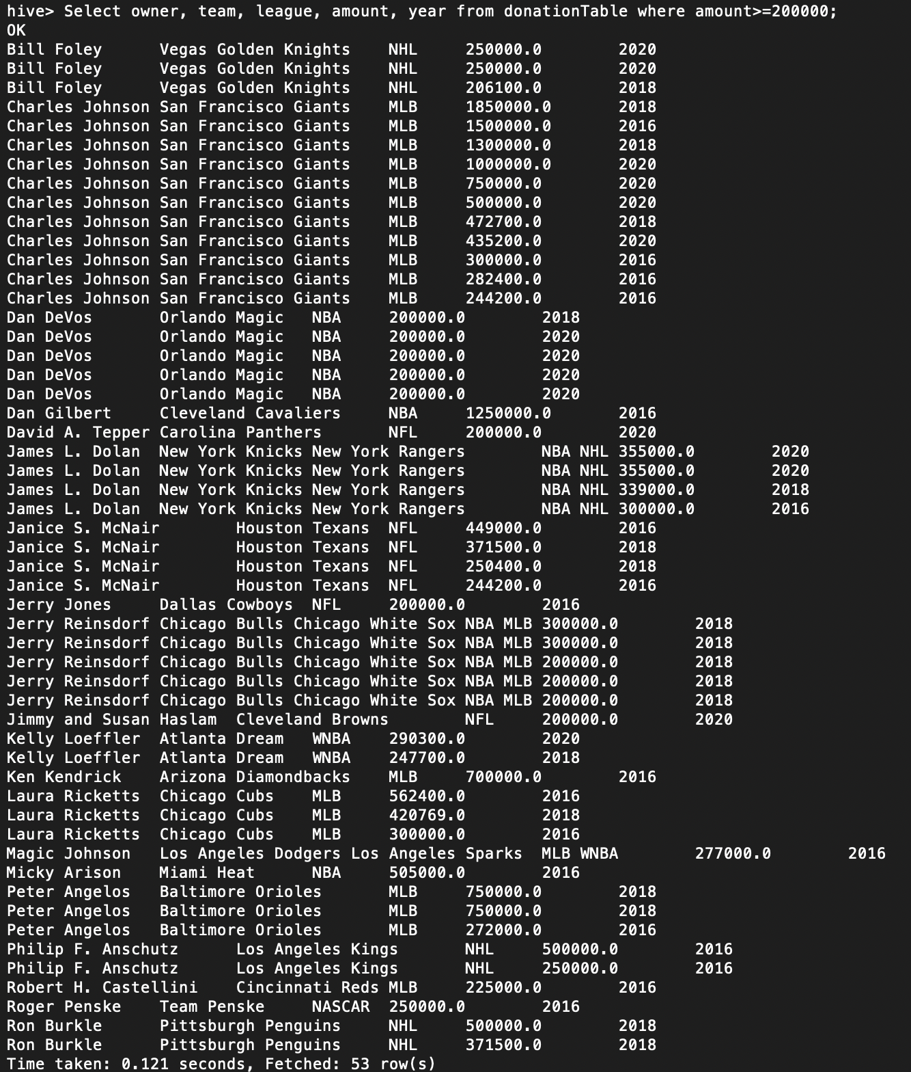

**Analysis #07 Show all distinct recipients**

*Select DISTINCT Recipient from donationTable;*

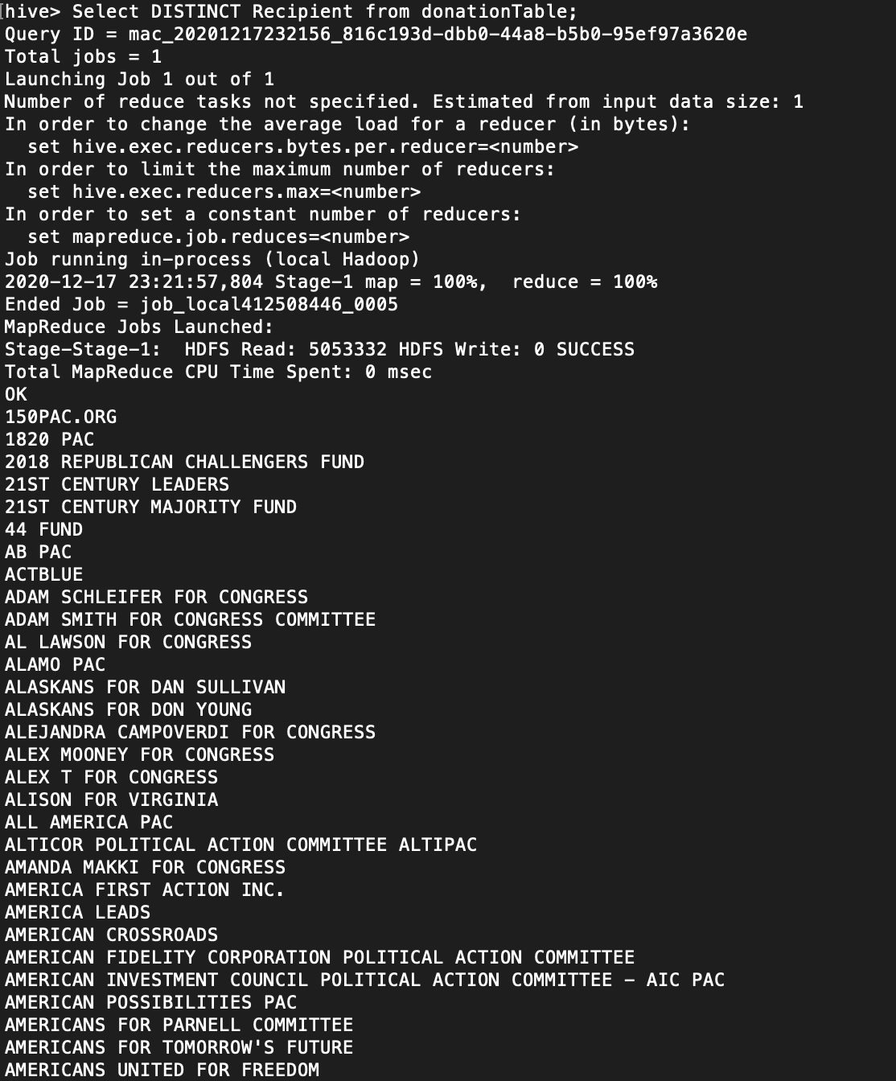

**Analysis #09 Find all donations from boston team**

*Select * FROM donationTable where team LIKE 'Boston%';*

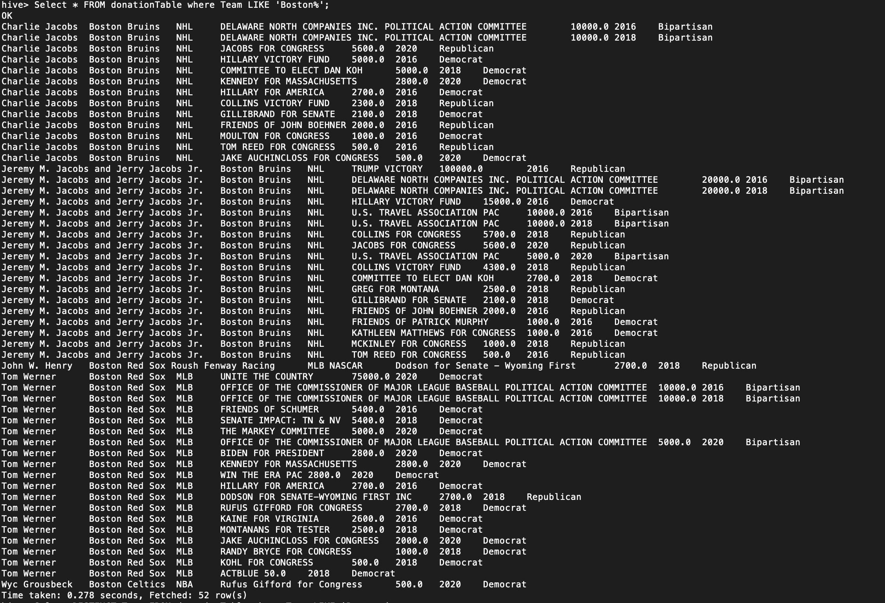

**Analysis #10 Count donation times from Boston team owner**

*Select owner,team,count(*) FROM donationTable where team like 'Boston%' GROUP BY owner,team;*

